Experiment 3: Creation of a Simple Network Topology Using Open-Source Network Virtualization Tools

Objective
To create and configure a simple network topology using an open-source network virtualization tool and verify communication between the virtual network nodes.

Task
- Ubuntu Linux Virtual Machine
- VirtualBox
- Mininet
- Create simple Network Topology • ping and basic Linux networking commands
- After completion, stop the network.

Mininet Installation
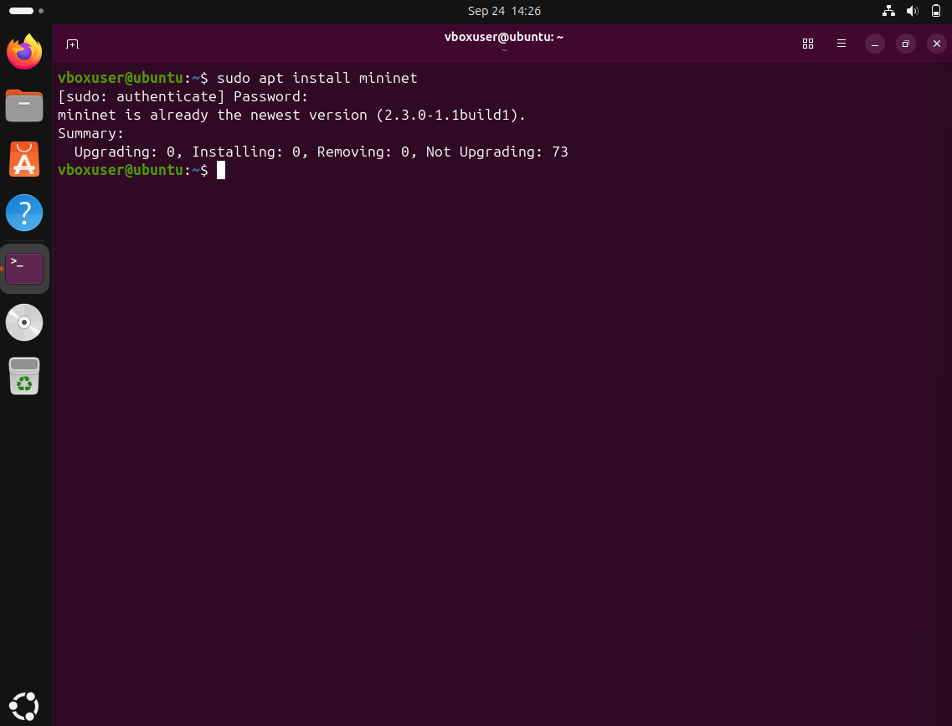

Topology
- Single/Star Topology
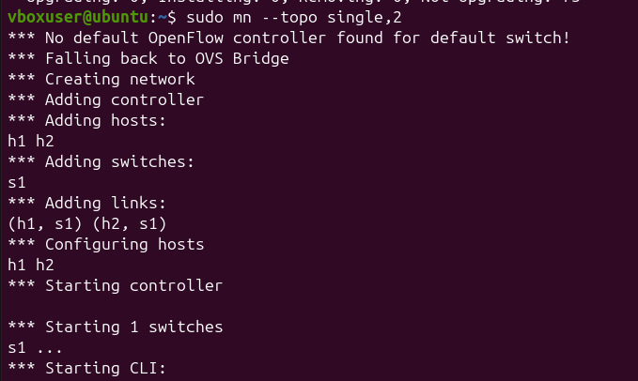

Links and Pingall

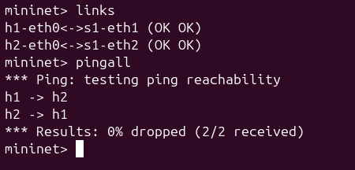

Diagram:
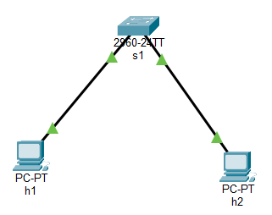

- Single with 5 hosts
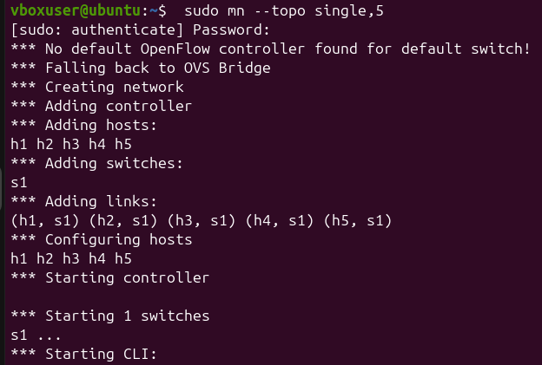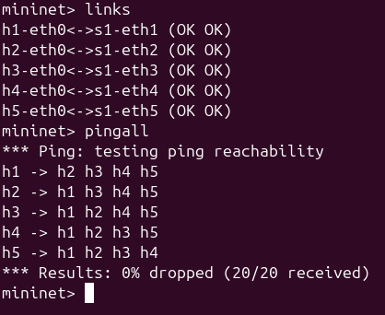
Creation Links and Pingall

Diagram:
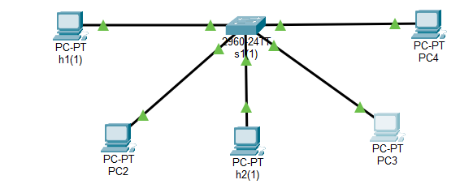

- Tree Topology
- Tree with 4 hosts
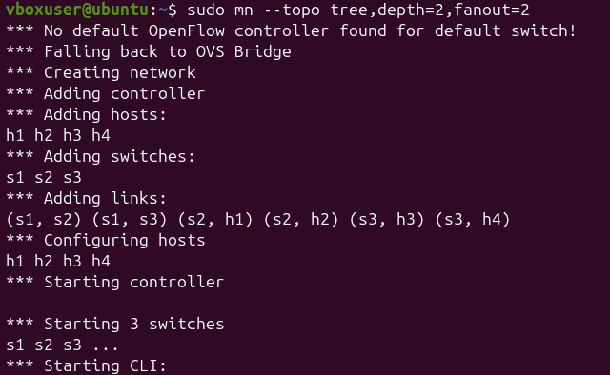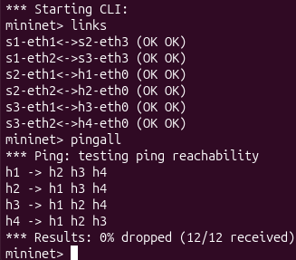
Creation Links and Pingall

Diagram:
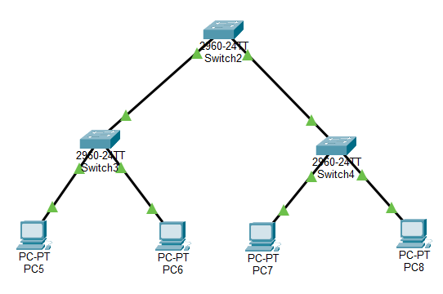

- Tree with 9 hosts
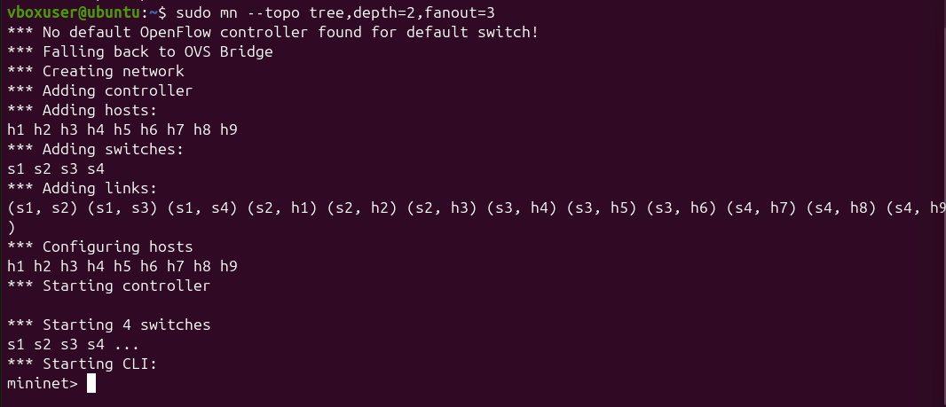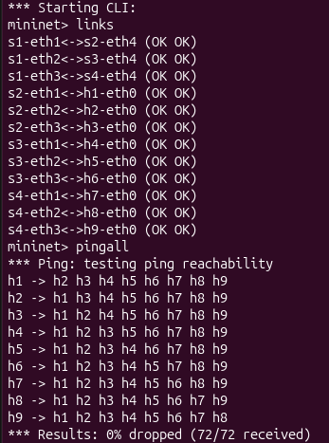
Links and Pingall

Diagram:
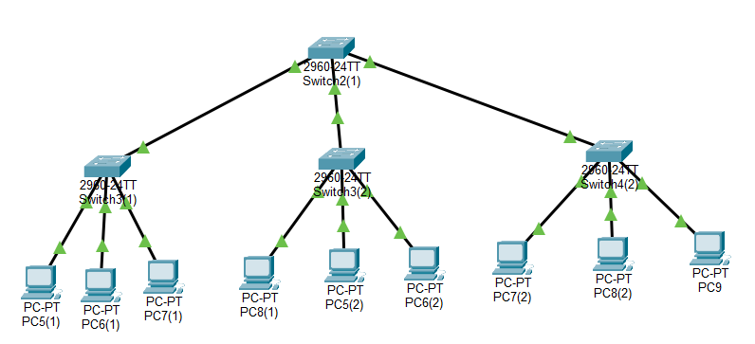

- Bus/Linear topology
- Linear with 3 hosts
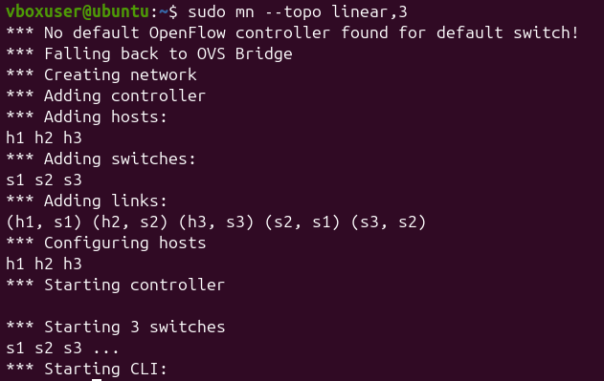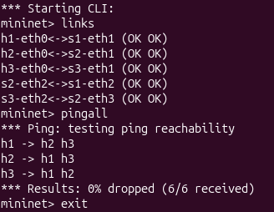
Links and Pingall

Diagram:
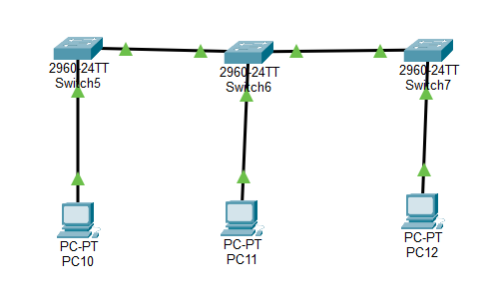

- Linear with 5 hosts
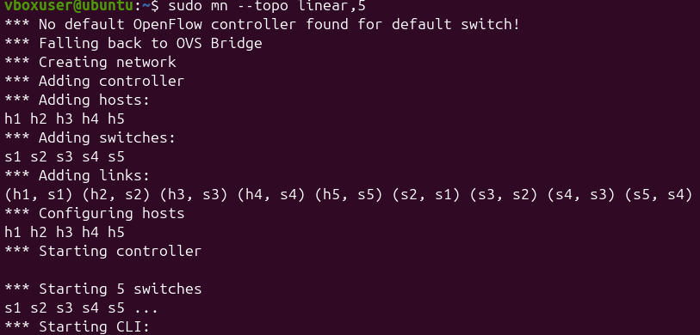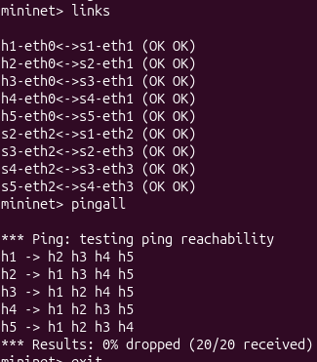
Links and Pingall

Diagram:
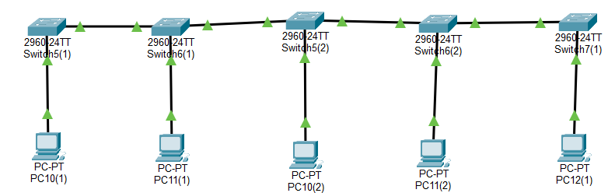

- Ring Topology
- Ring with 4 hosts

Creation: ring_a.py
from mininet.topo import Topo
from mininet.net import Mininet
from mininet.node import OVSSwitch
from mininet.cli import CLI

class RingTopo(Topo):
def build(self):
s1 = self.addSwitch('s1')
s2 = self.addSwitch('s2')
s3 = self.addSwitch('s3')
s4 = self.addSwitch('s4')

h1 = self.addHost('h1')
h2 = self.addHost('h2')
h3 = self.addHost('h3')
h4 = self.addHost('h4')

self.addLink(h1, s1)
self.addLink(h2, s2)
self.addLink(h3, s3)
self.addLink(h4, s4)

self.addLink(s1, s2)
self.addLink(s2, s3)
self.addLink(s3, s4)
self.addLink(s4, s1)

topo = RingTopo()
net = Mininet(topo=topo, switch=OVSSwitch, controller=None)
net.start()

# Enable STP on all switches
for s in net.switches:
s.cmd('ovs-vsctl set-fail-mode', s.name, 'standalone')
s.cmd('ovs-vsctl set Bridge', s.name, 'stp_enable=true')

print('\nRing topology started successfully.')
print('STP enabled on all switches.')
print('Type links and pingall at the Mininet prompt.\n')

CLI(net)

net.stop()

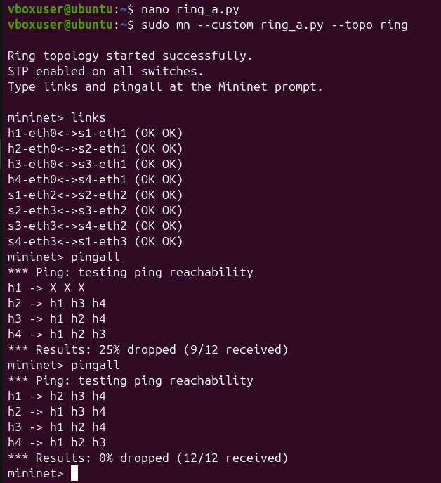
links and pingall

Diagram:
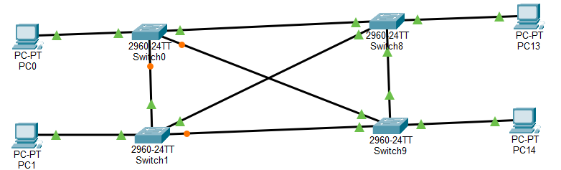

- Ring with 6 hosts
Creation: ring_b.py
from mininet.topo import Topo
from mininet.net import Mininet
from mininet.node import OVSSwitch
from mininet.cli import CLI

class RingTopo(Topo):
def build(self):
switches = [self.addSwitch(f's{i}') for i in range(1, 7)]
hosts = [self.addHost(f'h{i}') for i in range(1, 7)]

for i in range(6):
self.addLink(hosts[i], switches[i])

for i in range(6):
self.addLink(switches[i], switches[(i + 1) % 6])

topo = RingTopo()
net = Mininet(topo=topo, switch=OVSSwitch, controller=None)

net.start()

for s in net.switches:
s.cmd('ovs-vsctl set Bridge', s.name, 'stp_enable=true')
s.cmd('ovs-vsctl set-fail-mode', s.name, 'standalone')

print("\n6-node Ring topology started successfully.")

CLI(net)

net.stop()

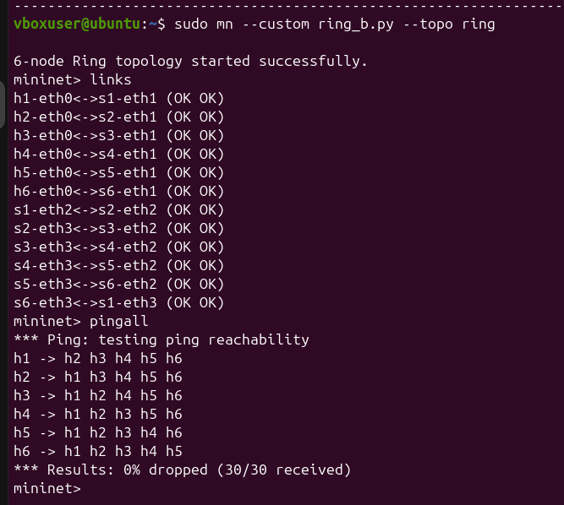
links and pingall

Diagram:
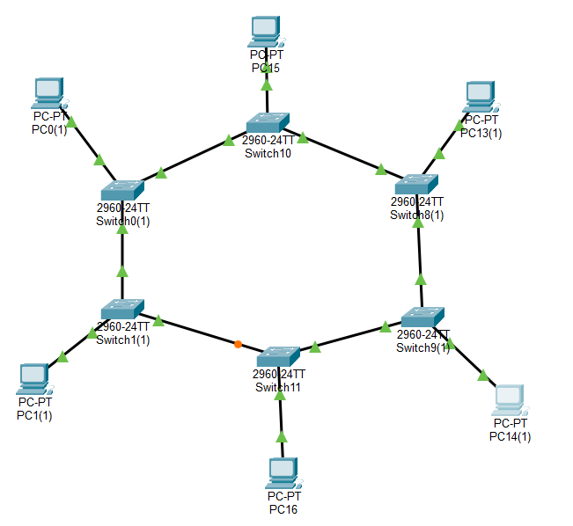
- Mesh Topology
- Mesh with 3 hosts
Creation: mesh_a.py

from mininet.topo import Topo
from mininet.net import Mininet
from mininet.node import OVSSwitch
from mininet.cli import CLI

class MeshTopo(Topo):
def build(self):
switches = [self.addSwitch(f's{i}') for i in range(1, 5)]
hosts = [self.addHost(f'h{i}') for i in range(1, 5)]

for i in range(4):
self.addLink(hosts[i], switches[i])

for i in range(4):
self.addLink(switches[i], switches[(i + 1) % 4])

topo = MeshTopo()
net = Mininet(topo=topo, switch=OVSSwitch, controller=None)

net.start()

for s in net.switches:
s.cmd('ovs-vsctl set Bridge', s.name, 'stp_enable=true')
s.cmd('ovs-vsctl set-fail-mode', s.name, 'standalone')

print("\n4-hosts mesh topology started successfully.")

CLI(net)

net.stop()

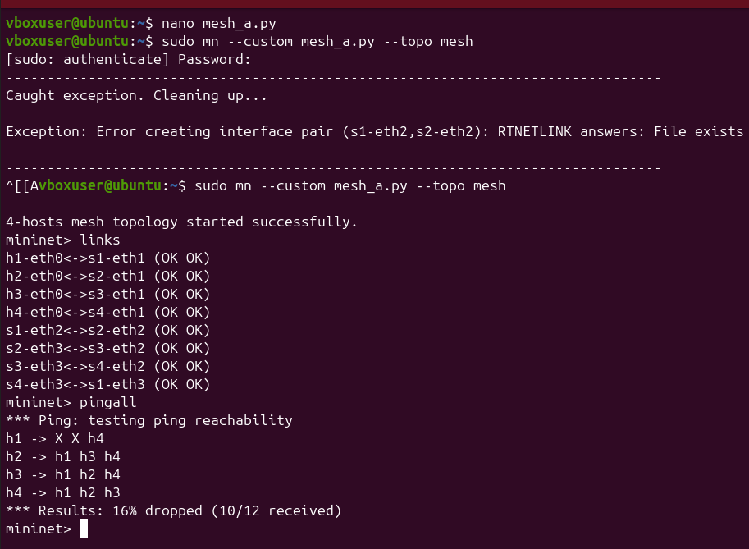
links and pingall

Diagram:
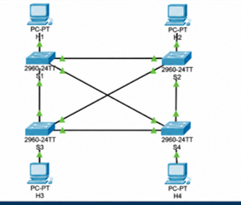

- mesh with 6 hosts
Creation: mesh_b.py

from mininet.topo import Topo
from mininet.net import Mininet
from mininet.node import OVSSwitch
from mininet.cli import CLI

class MeshTopo(Topo):
def build(self):
switches = [self.addSwitch(f's{i}') for i in range(1, 7)]
hosts = [self.addHost(f'h{i}') for i in range(1, 7)]

for i in range(6):
self.addLink(hosts[i], switches[i])

for i in range(6):
self.addLink(switches[i], switches[(i + 1) % 6])

topo = MeshTopo()
net = Mininet(topo=topo, switch=OVSSwitch, controller=None)

net.start()

for s in net.switches:
s.cmd('ovs-vsctl set Bridge', s.name, 'stp_enable=true')
s.cmd('ovs-vsctl set-fail-mode', s.name, 'standalone')

print("\n6-hosts mesh topology started successfully.")

CLI(net)

net.stop()
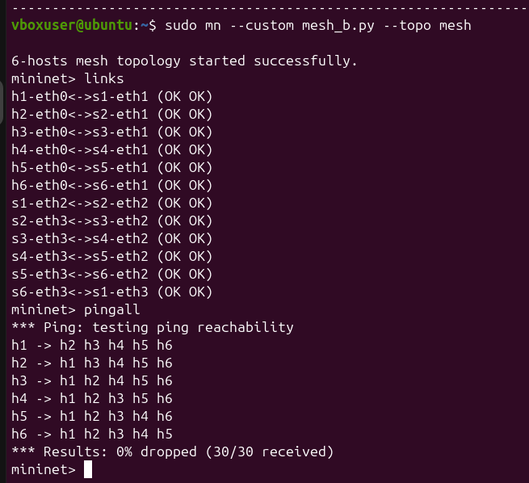

Diagram:
